Module 1
Develop an instrumentation strategy
Enable and configure App Service application logging
What are app logs?
App logs are the output of runtime trace statements in app code. For example, you might want to check some logic in your code by adding a trace to show when a particular function is being processed, or you might only want to see a logged message when a particular level of error has occurred. App logging is primarily for apps in pre-production and for troublesome issues, because excessive logs can carry a performance hit and quickly consume storage;

App logging has scale limitations, primarily because files are being used to save the logged output.

ASP.NET
ASP.NET apps only run on Windows app services. To log information to the app diagnostics log, use the System.Diagnostics.Trace class. There are four trace levels you can use, and these correlate with error, warning, information, and verbose logging levels shown in the Azure portal:
- Trace.TraceError("Message"); // Writes an error message
- Trace.TraceWarning("Message"); // Writes a warning message
- Trace.TraceInformation("Message"); // Writes an information message
- Trace.WriteLine("Message"); // Writes a verbose message

ASP.NET Core apps
ASP.NET Core apps can run on either Windows or Linux. To log information to Azure app logs, use the logger factory class, and then use one of six-log levels:
- logger.LogCritical("Message"); // Writes a critical message at log level 5
- logger.LogError("Message"); // Writes an error message at log level 4
- logger.LogWarning("Message"); // Writes a warning message at log level 3
- logger.LogInformation("Message"); // Writes an information message at log level 2
- logger.LogDebug("Message"); // Writes a debug message at log level 1
- logger.LogTrace("Message"); // Writes a detailed trace message at log level 0

App environment | Host | Log levels | Save location
ASP.NET | Windows | Error, Warning, Information, Verbose | File system, Blob storage
ASP.NET Core | Windows | Error, Warning, Information, Verbose | File system, Blob storage
ASP.NET Core | Linux | Error | File system
Node.js | Windows | Error (STDERR), Information (STDOUT), Warning, Verbose | File system, Blob storage
Node.js | Linux | Error | File system
Java | Linux | Error | File system

Azure Application Insights is a site extension that provides additional performance monitoring features, such as detailed usage and performance data, and is designed for production app deployments as well as being a potentially useful development tool.

Enable logging using the Azure portal
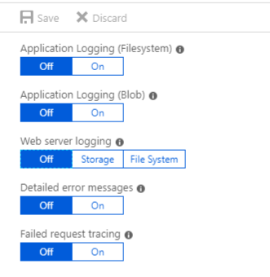
To enable app logging to the Web app's file system, set Application logging (Filesystem) to On, and then set the Level to Error, Warning, Information, or Verbose. Logging to the file system will be automatically reset to Off after 12 hours.
To enable app logging to a blob storage container, set Application logging (Blob) to On, and then select a storage account and container; the storage account and Web app must be created in the same Azure region. You then set the Level to Error, Warning, Information, or Verbose.
When logging to blob storage, you must also set a Retention Period. Unlike the file system logs, blob logs are never deleted by default; the retention period option means that any logs older than the specified number of days will be deleted.
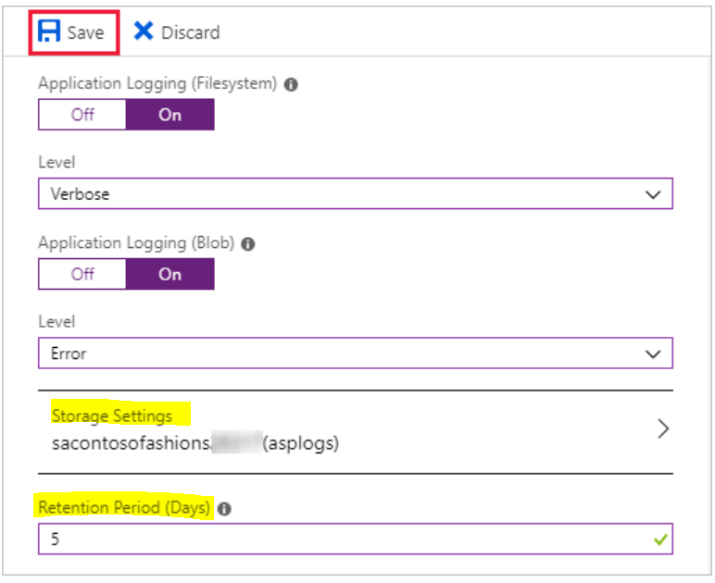

Enable logging using the Azure CLI
az webapp log config --application-logging true --level verbose --name <app-name> --resource-group <resource-group-name>
There is currently no way to disable application logging by using Azure CLI commands; however, the following command resets file system logging to error-level only.
az webapp log config --application-logging false --name <app-name> --resource-group <resource-group-name>
To view the current logging status for an app, use this command.
az webapp log show --name <app-name> --resource-group <resource-group-name>

What is live log streaming?
Live log streaming is an easy and efficient way to view live logs for troubleshooting purposes. Live log streaming is designed to provide a quick view of all messages that are being sent to the app logs in the file system, without having to go through the process of locating and opening these logs.
az webapp log tail --name <app name> --resource-group <resource group name>

Curl
To use Curl, you need FTPS credentials. There are two types of FTPS credentials:
- Application scope. Azure automatically creates a username/password pair when you deploy a Web app, and each of your apps has their own separate set of credentials.
- User scope. You can create your own credentials for use with any Web app; you can manage these credentials in the Azure portal, as long as you already have at least one Web app, or by using Azure CLI commands.
az webapp deployment user set --user-name <name-of-user-to create> --password <new-password>
curl -u {username} https://{sitename}.scm.azurewebsites.net/api/logstream

Windows app log files
For Windows apps, file system log files are stored in a virtual drive that is associated with your Web App. This drive is addressable as D:\Home, and includes a LogFiles folder; within this folder are one or more subfolders:
- Application - Contains application-generated messages, if File System application logging has been enabled.
- DetailedErrors - Contains detailed Web server error logs, if Detailed error messages have been enabled.
- http - Contains IIS-level logs, if Web server logging has been enabled.
- W3SVC<number> - Contains details of all failed http requests, if Failed request tracing has been enabled.

To download file system log files using the Azure CLI, first copy the log files from the app's file system to Cloud Shell storage, and then run the following command.
az webapp log download --log-file \<_filename_\>.zip --resource-group \<_resource group name_\> --name \<_app name_\>

Kudu
All Azure Web Apps have an associated Source Control Management (SCM) service site. This site runs the Kudu service, and other Site Extensions; it is Kudu that manages deployment and troubleshooting for Azure Web Apps, including options for viewing and downloading log files.
One way to access the KUDU console is navigate to https://<app name>.scm.azurewebsites.net, and then sign in using deployment credentials.
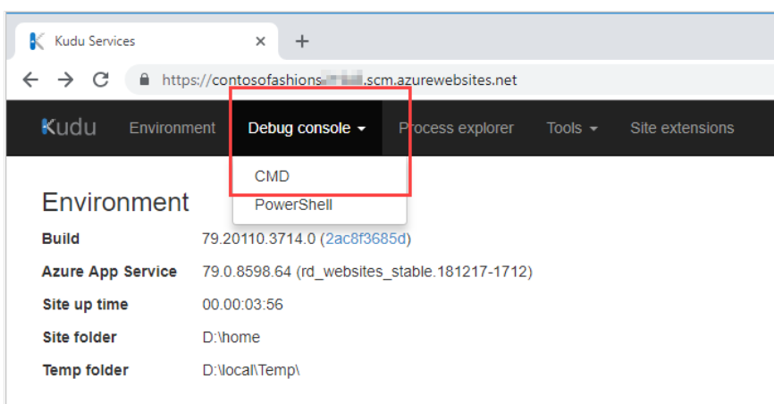
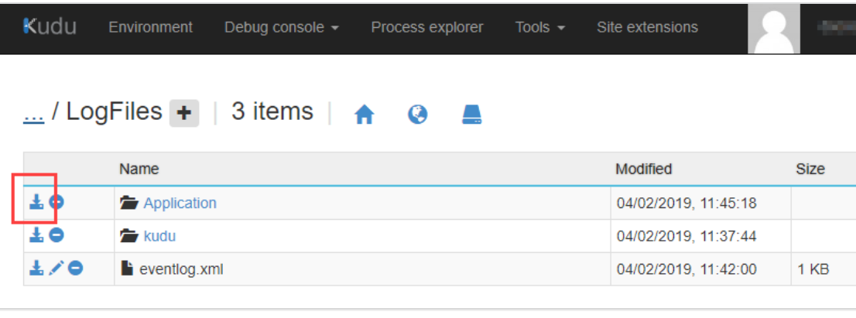

Azure Storage Explorer
To access Windows logs saved to an Azure Blob Storage container, you can use the Azure portal; to view and download the contents of the log file container, select Storage Explorer. Open the relevant year, month, date, and hour folder, then double-click a CSV file to download it to your computer.
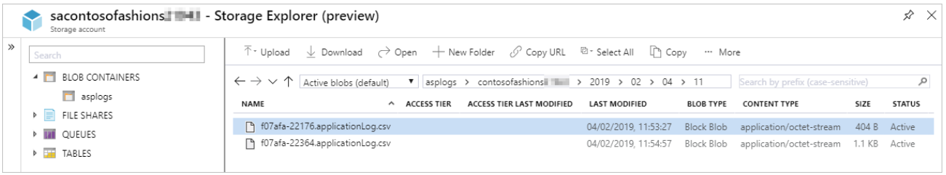

Introduction to Site Reliability Engineering

What is SRE and why does it matter?

Site Reliability Engineering is an engineering discipline devoted to helping an organization sustainably achieve the appropriate level of reliability in their systems, services, and products.
The two operations practices, DevOps and SRE, share a mutual love of monitoring/observability and automation (perhaps for different reasons). This is one reason why it can often be easier to import SRE practices and principles into an organization with an existing DevOps practice.
Service Level Objective (SLO).

Develop a security and compliance plan

What is Azure AD?
Azure AD is a cloud-based identity management solution. It helps your company's internal users to:
- Access external resources, like Azure services, Microsoft 365, and third-party SaaS applications.
- Access internal resources such as applications on your corporate network, and cloud-based applications that your company builds.
Azure AD also helps you keep user identities and applications secure through features like Conditional Access and identity protection.

Who benefits from Azure AD?
Azure AD meets the needs of many types of users. For instance, an IT administrator can use Azure AD to determine who should have access to applications and resources, based on company requirements. An administrator can add another layer of protection to applications and services by enforcing multi-factor authentication on sign-ins.
Application developers can use Azure AD to enable users to use preexisting credentials to access applications. Developers also use Azure AD to create personalized end-user experiences by accessing organizational user data through APIs that are specific to Azure AD.
If you subscribe to services like Azure or Microsoft 365, you're already taking advantage of Azure AD. You could use Azure AD to further manage access to your cloud applications.

Identity secure score in Azure AD
If you're an administrator, you need to know how secure your Azure AD tenant is. The identity secure score can help you understand. Azure AD gives an overall value between 1 and 223. This value represents how well you match the recommendations and best practices that Microsoft suggests for tenant security. The identity secure score reveals how effective your security is and helps you implement improvements.
HOW AZURE AD COMPARES WITH ACTIVE DIRECTORY
Service | Authentication | Structure | What it's used for
Active Directory | Kerberos, NTLM | Forests, domains, organizational units | Authentication and authorization for on-premises printers, applications, file services, and more
Azure Active Directory | Includes SAML, OAuth, WS-Federation | Tenants | Internet-based services and applications like Microsoft 365, Azure services, and third-party SaaS applications

Hybrid identity for linking on-premises Active Directory with Azure AD
Multiple authentication methods let you achieve hybrid identity for users:
- Azure AD password hash synchronization. Here, the user's password is hashed twice and synchronized between the on-premises Active Directory and Azure AD. Users have the same credentials to access resources and applications both on-premises and in the cloud.
- Azure AD pass-through authentication. Here, an agent is installed on on-premises servers that authenticate against the on-premises Active Directory. When an Azure AD user account tries to authenticate, password authentication is handled on-premises through these servers and Active Directory.
- Federated authentication. Here, the authentication process is performed by an on-premises Active Directory Federation Services (AD FS) server that validates users' passwords. Use this authentication method if you want advanced measures like smart card-based authentication for users.
You want to: | Password hash synchronization | Pass-through authentication | Federated authentication
Automatically synchronize to the cloud the users, contacts, and groups that have been set up on on-premises Active Directory. | Yes | Yes | Yes
Allow users to access cloud applications and resources by using their on-premises password. | Yes | Yes | Yes
Ensure that password hashes aren't stored in the cloud. | No | Yes | Yes
Use cloud-based multi-factor authentication. | Yes | Yes | Yes
Use on-premises multi-factor authentication. | No | No | Yes
Use smart card authentication for additional protection. | No | No | Yes

If you're a customer who uses an address in Europe, Azure AD stores most of your data in European datacenters. However, some data is stored outside Europe by services that you use with Azure AD
Following are stored in US
Azure Active Directory B2B (Azure AD B2B)
Azure Active Directory B2C (Azure AD B2C)
Azure AD Multi-Factor Authentication

Azure AD licenses
You can use different features of Azure AD, depending on the type of license you choose:
- Azure Active Directory Free. You can manage users and groups, and you get necessary reports, on-premises Active Directory synchronization, and self-service password reset for Azure AD users. You also get single sign-on for Microsoft 365, Azure services, and many third-party SaaS applications.
- Pay-as-you-go licenses for specific features. You access specific Azure AD features, like Azure AD B2C, on a pay-as-you-go basis. Azure AD B2C lets you manage identity and access for consumer users and the applications they use.
- Office 365 Apps. You get all of the free tier features, but you can also have custom login and logout pages, self-service password reset for cloud users and device write-back.
- Azure Active Directory Premium P1. You get all the features from the free tier, but you can also let users access on-premises and cloud-based services and resources. You can use self-service group management or dynamic groups, where users are added and removed automatically, based on your criteria. This tier supports on-premises identity management suites like Microsoft Identity Manager. Self-service password reset is also supported for users who are based on-premises.
- Azure Active Directory Premium P2. You get all the features of the previous two tiers, along with Active Directory Identity Protection. This feature helps you configure risk-based Conditional Access to protect applications from identity risks. You can also use privileged identity management, which lets you monitor and put detailed restrictions on administrators.

Azure AD terminology
To use Azure AD effectively, you need to understand some key Active Directory terms.
Here's an explanation of some of those terms:
AZURE AD TERMINOLOGY
Term | Description
Identity | Something that has to be identified and authenticated. An identity is typically a user with a username and password credentials, but the term can also apply to applications or services.
Account | An identity and its associated data. An account can't exist without an identity.
Azure AD account | An identity created in Azure AD or in services like Microsoft 365. These identities are stored in Azure AD. For example, internal staff members might use Azure AD accounts daily at work.
Azure subscription | Your level of access to use Azure and its services. For pay-as-you-go access, use your credit card to set up an Azure subscription. There are several types of subscriptions. For example, enterprise-level customers can use Azure Enterprise Agreement subscriptions. Each account can use many subscriptions.
Azure AD tenant | An instance of an Azure AD. This tenant is automatically created for you when you first sign up for Azure or other services like Microsoft 365. A tenant, which represents an organization, holds your users, their groups, and applications.
Multi-tenant | Multiple-tenant access to the same applications and services in a shared environment. These tenants represent multiple organizations.
Azure AD directory | An Azure resource that's created for you automatically when you subscribe to Azure. You can create many Azure AD directories. Each of these directories represents a tenant.
Custom domain | A domain that you customize for your Azure AD directory. When you create an Azure AD directory, Azure automatically assigns it a default domain like <your-organization>.onmicrosoft.com. But you can customize domain names. Your users could then have accounts like joesmith@contoso.com instead of joesmith@contoso.onmicrosoft.com.
Owner role | The role you use to manage all Azure resources, including the access levels that users need for resources.
Global administrator | The role that gives you access to all administrative capabilities in Azure AD. When you create a tenant, you automatically have this role for the tenant. This role allows you to reset passwords for all users and administrators, for example.

Comparison of member and guest default permissions
Here are some of the default permissions for member users and guest users:
COMPARISON OF MEMBER AND GUEST DEFAULT PERMISSIONS
Area | Member user permissions | Guest-user permissions
Users and contacts | Can view all profile details. Can change own password, mobile phone number, and profile photos. | Can view only profile name, email, sign-in name, photo, user principal name, and user type properties of other users and contacts. Can change own password.
Devices | Can read all properties of devices. Can manage all properties of owned devices. | Can't read all properties of devices. Can't manage all properties of owned devices. Can delete owned devices.
Applications | Can register new applications. | Can't register new applications. Can delete owned applications.
Policies | Can read all properties of policies and manage all properties of owned policies. | No permissions.
Subscriptions | Can read all subscriptions and enable service plan members. | No permissions.
Roles and scopes | Can read all administrative roles and memberships. Can read all roles and scopes and membership of administrative units. | No per

Azure AD B2B
Use Azure AD to invite external users to your tenant. Your organization can then collaborate with external healthcare partner staff members through Azure AD B2B Collaboration.

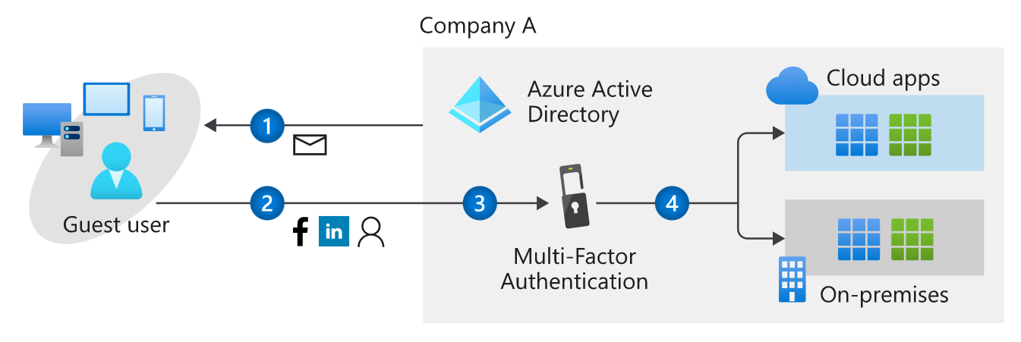
- The external user either receives an email invitation that includes a redemption link or gets a direct link.
- The user selects the redemption link to access the apps they were invited to.
- If multi-factor authentication is set up, the user receives a verification code on their phone.
- The user provides the code they received.
- The user can access the app, whether it's on-premises or in the cloud.
This feature is available for all licensing tiers in Azure AD.

Azure AD B2C
You can also use Azure AD B2C to manage your customers' identities and access. Your doctors' accounts should have protected access to resources and services. Use Azure AD B2C to securely authenticate the doctors through their preferred identity providers.
AD B2C also helps you monitor for threats like brute force attacks and denial-of-service attacks on doctors' user accounts. To use Azure AD B2C, you register your apps. You then configure user flows to set up the user's journey to access an app.
For example, a flow for the sign-in process might go like this:
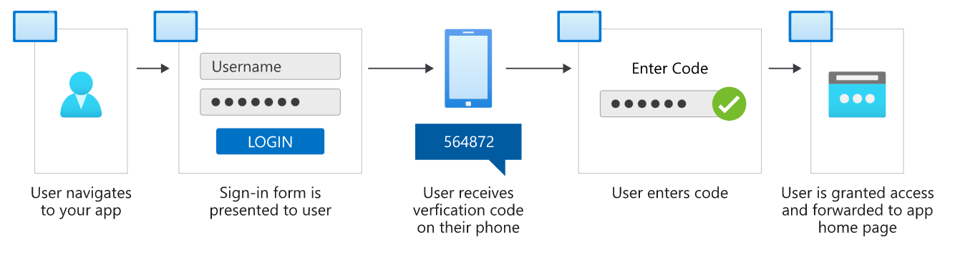
- On their browser or mobile phone, the user goes to the app they want to access.
- The user is required to complete the sign-in form.
- If the credentials are verified and multi-factor authentication is enabled, the user receives a verification code on their phone.
- The user provides the code they received.
- The user is granted access to the app.
This feature is available on a pay-as-you-go basis.

Azure AD DS
Azure AD DS lets you add virtual machines to a domain without needing domain controllers. Your internal staff users can access virtual machines by using their company Azure AD credentials.
Use this service to reduce the complexity of migrating on-premises apps to Azure. An organization could also use Azure AD DS to handle its infrastructure if it runs apps both on-premises and in the cloud. The process might go like this:
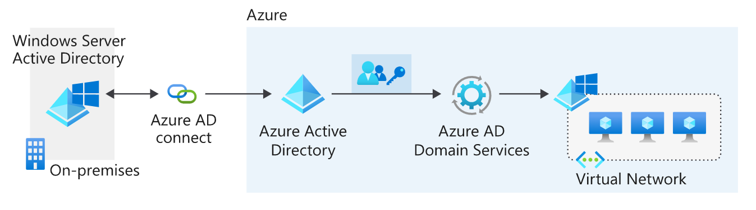
- The organization deploys its apps and servers in a virtual network on Azure.
- Azure AD Connect sync synchronizes identity information between the on-premises Active Directory instance and the organization's tenant in Azure AD.
- The company enables Azure AD DS on their Azure AD tenant.
- The apps and servers in Azure can use features like domain joining and Kerberos authentication.
This feature is available for pay-as-you-go, based on the total number of objects in your domain that's managed by Azure AD DS. Objects can include users, groups, and domain-joined computers.

App management
Your company might provide many apps that internal and external users rely on. Users might want to access these apps from different devices and locations. You can use Azure AD as a cloud-based solution to manage user access for all of these apps.

Azure AD App Gallery applications. Thousands of SaaS apps are integrated with Azure AD. Find these apps in Azure Marketplace.
Custom applications. You can register your company-built apps with Azure AD. You then control and monitor authentication for these apps.
Non-gallery applications. You can manually add any apps that you don't see in the gallery.
On-premises applications. You can add on-premises apps by configuring Azure AD Application Proxy. This process creates secure remote access for your on-premises apps. To connect them, download and install the Application Proxy connector on-premises.

Use conditional-access policies to require users to pass additional authentication challenges before they access an app. For example, you can configure a conditional-access policy to require users to complete a multi-factor authentication challenge after their credentials are verified and before they access the app.

Monitor your app access
Azure AD can help monitor your app sign-ins by generating reports that cover sign-in dates, user details, apps the user has used, risk detection, location, and more. Access those reports through the Azure portal or specific APIs for programmatic usage.
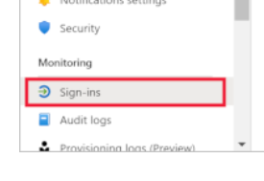

Azure AD Identity Protection
Azure AD Identity Protection helps you to automatically detect, investigate, and remediate identity risks for users. Identity Protection also lets you export all the information that was collected about risks. Export the information to third-party tools and solutions so that you can further analyze it.
Identity Protection uses risk policies to automatically detect and respond to threats. You configure a risk policy to set up how Identity Protection should respond to a particular type of risk. Use policies in this way to save time and give you peace of mind.
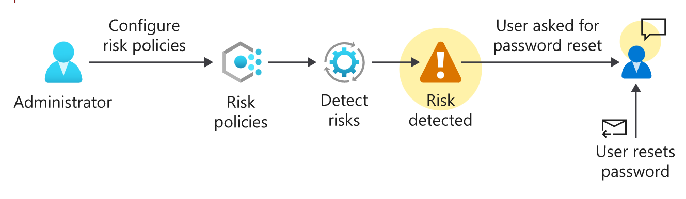

Deploy in phases

Stage 1: Build a secure foundation
Assign more than one global administrator.
Use regular administrative roles where possible.
Configure Privileged Identity Management (PIM) to track administrators. - Azure AD Premium P2
Configure self-service password reset.
Create a list of banned passwords.
Warn users to not reuse credentials.
Set passwords to never expire for cloud-based user accounts.
Enforce multi-factor authentication through conditional-access policies - Azure AD Premium P1
Configure Azure Active Directory Identity Protection (AADIP) - Azure AD Premium P1

Stage 2: Add users, manage devices, and configure synchronization
Install and configure Azure AD Connect.
Use password hash synchronization.
Use password writeback - Azure AD Premium P1
Use Azure AD Connect Health - Azure AD Premium P1
Give users the licenses they need at a group level.
Use Azure AD B2B Collaboration for guest-user access.
Prepare a device-management strategy.
Provide authentication methods that don't require passwords - Azure AD Premium P1

Stage 3: Manage your applications
Identify applications.
Use SaaS applications in the Azure AD gallery.
Integrate your on-premises applications by using Application Proxy.

Stage 4: Monitor your administrators, do access reviews, and automate user life cycles

Use PIM to control administrator access - Azure AD Premium P2
Complete access reviews for Azure AD directory roles in PIM - Azure AD Premium P2
Configure dynamic group membership policies - Azure AD Premium P2
Use group-based application assignment.
Configure automated user account provisioning and deactivation.

Create a tenant
After you lay the groundwork for your instance of Azure AD, you can begin to configure and start using it. You need to create a tenant, which is considered a resource in Azure.
Use the Azure portal to create a tenant and a new Azure AD resource.

Associate a subscription
After you create your tenant, associate it with a subscription. In the Azure portal, go to your subscription and change it to your new directory.

Manage source control

